The Arctic Wilderness Adventure Recommended Flights

11th – 14th January 2019
Please note: If you search London Gatwick to Kiruna, the suggested route below should appear in the results.

Outbound:
LGW – Stockholm Arlanda
Norwegian Air International
Friday 11th Jan 2019 06:20am
Terminal: S
Flight Number: DY2850

(Connecting Flight) Stockholm-Arlanda – Kiruna
Norwegian Air Shuttle
Friday 11th Jan 10:50am
Terminal:4
Flight Number: DY4063

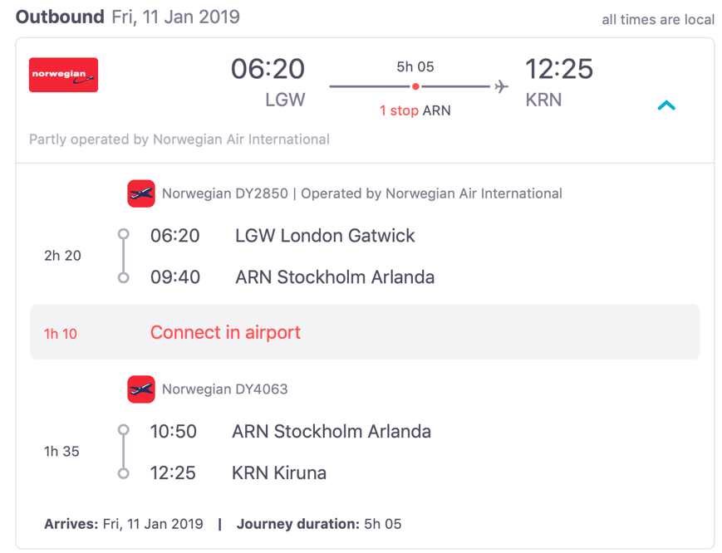

Inbound
Kiruna – Stockholm-Arlanda
Norwegian Air Shuttle
Monday 14th Jan 2019 12:55
Flight Number: DY4064

Stockholm Arlanda – London-Gatwick
Norwegian Air International
Monday 14th Jan 2019 17:40
Terminal: 5
Flight Number: DY2857

